Problems:
Problem I have in this project is Single-Sign On (SSO), because there is no api to do that.
In the “Innovation day” power point file, there is no future plan for “Gear Go!” Project, so I assume this is a management application.

Solutions:
Load the whole login web page for users to login their accounts, then proceed with OAuth 2.0. After login, use the API that OPSWAT provides to load the devices of user.

Apache Cordova
Cordova – a framework for creating a cross-platform mobile application using HTML5 and javascript.
Why I choose cordova?
- Because it is HTML5 and javascript, so it can be built to any platforms that Cordova supports (even FireOS and Tizen are supported). “One code, run anywhere”. This will reduce the cost of development cycle.
- Developers can create stunning UI with HTML5 and CSS3.
- This application's performance mostly depends on internet connection. So native application maybe not required.
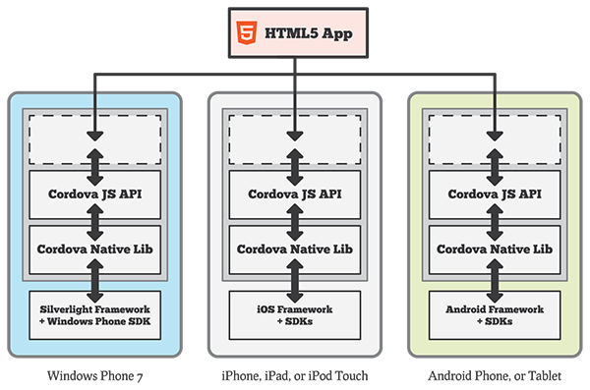

- According to http://msdn.microsoft.com/en-us/magazine/hh975345.aspx there is 2 ways to develop an application using cordova sdk: single page or multiple page. In my project, I use single page to view dashboard and device details.

Manual:
In the first page, there should be 1 button “Authorize”, tap it. This will lead to login page of Opswat, login to your account, sometimes there will be authorize page, tick authorize button and submit.
After that, it will list all your devices, tap on any device to view device detail (this action will send a request to get device detail). In device detail page, there is a button in the bottom, tap it to go back to dashboard (this action will send a request to get all devices).

Suggest to improve:
- Documentation needs to be updated on the developer website. I found an example is not correct (I only work on 2 rest apis so I only check 2 of them).
- In the java guide (sample apps section), authorization page image is not up to date.
- In my project, I load the login page of OPSWAT and it's not user friendly. I suggest that we should have an sdk to take care of the login process, or make the login page for mobiles.

Limitation and known issues:
- There hasn't been a way to allow user to sign out or revoke token access yet.
- Not compatible with many types of devices' screen.

